This is a board to adapt a 433Mhz Dorji DRF1278F lora module into a breadboard friendly format. The board will allow you to use the DRF1278F with a standard 0.1” matrix breadbord or stripboard.
The antenna cannection can be either a simple wire, U.FL connector or an edge SMA socket. The boards are supplied with the 0.1" pins unsoldered, leaving you the option of how to assemble or use the board in a project.
This board can be used with the Easy mikroBUS™ Pro Mini controller available in this shop.

Do not operate the DRF1278F device without an antenna. The DRF1278F is a 3.3V supply and logic level device, do not use directly with 5V controller boards such as the Arduino UNO.
The pinout of the board is below, the lora device pins on the outside.
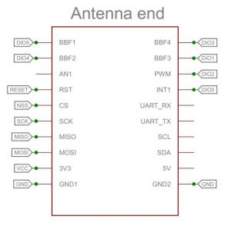
There are many examples for using these boards for GPS trackers or sensors provided in an Arduino the library here; https://github.com/StuartsProjects/SX12XX-LoRa

